Mini Air Compressor With Auto Cutoff

Compressed air is the core requirement of every large and medium scale industry. Along with industries air compressors are also useful in other general purpose tasks like bike/care air filling, spray painting and abrasive sand blowing etc. But usually air compressors come in heavy and mountable designs. Well we here design a mini compressor that is lightweight as well as portable to carry.
The compressor makes use of an AC motor along with a twin cylinder compressor pump coupled by a belt arrangement. We then use a metal cylinder to store compressed air. The arrangement is mounted with 6 wheels – 4 on base and 2 on back side enabling the user to carry it in a horizontal as well as vertical position.
The mini air compressor introduces following key aspects
- Efficient Air Compression
- Automatic Cutoff on Pressure Reach
- Front handle for easy gripping
- 6 wheel design for horizontal as well as vertical carrying
The AC motor is first connected to power supply to start its rotation. This power is now transferred to the twin cylinder pump by using a belt pulley arrangement. The pump now reciprocates pulling in air and pumping into the air tank continuously using the motor power. This system allows for an efficient continuous air supply into the tank.
The tank is also integrated with a pressure meter that is used to monitor the current air pressure. Also when the air pressure in the tank reaches a certain pressure the motor is automatically stopped to save power and avoid accident. The compressor is now mounted with a unique 6 wheel arrangement and a front handle to make it easy to carry and move around.

Approx Size: 500x400x450cm

Components
- AC Motor
- Belt and Pulley
- Air Tank
- Air Cylinders
- Pressure Gauge
- Reciprocating Arrangement
- Pistons
- Oil Chamber
- Oil Lid
- Wheels
- Base Frame
- Supporting Frame
- Mounts and Joints
- Screws and Bolts

Advantages
- Efficient Air Compression
- Automatic Cutoff on Pressure Reach
- Front handle for easy gripping
- 6 wheel design for horizontal as well as vertical carrying

Disadvantages
- Needs Oiling and Maintenance
- Cannot handle high pressures

Block Diagram
Front View
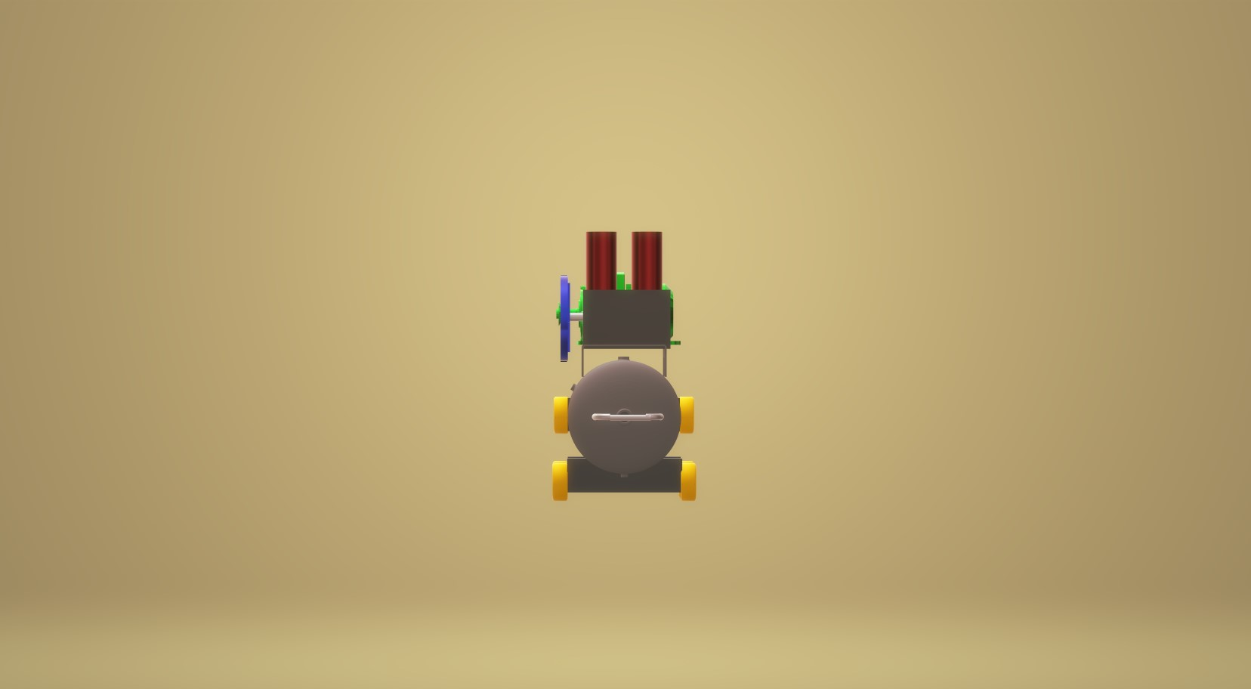
Side View
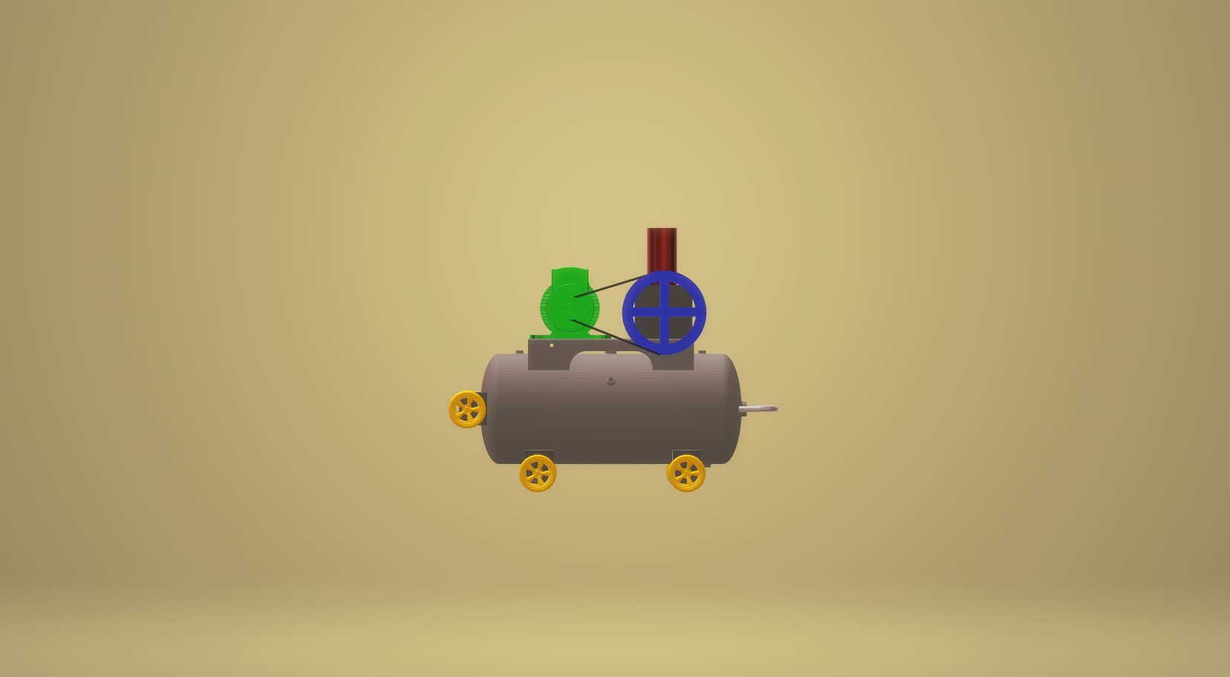

3D View
